DOCKER CONTAINERIZATION PRACTICAL-6
step-by-step student guide

1. Practical Question
Create and containerize a sample application using Docker by writing a Dockerfile, building the image, and running the container.

2. Requirements
- Docker Desktop -install docker desktop
- VS Code or any editor
- Terminal / PowerShell
- Web browser

3. Docker Concepts
Dockerfile = build instructions | Image = packaged application | Container = running instance of an image

4. Step 1 — Check Docker
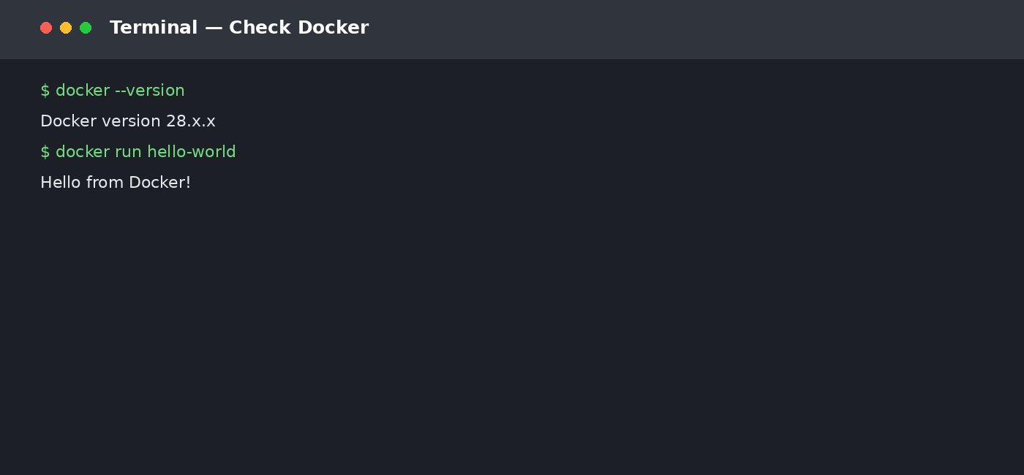
docker --version
docker run hello-world

5. Step 2 — Create Project
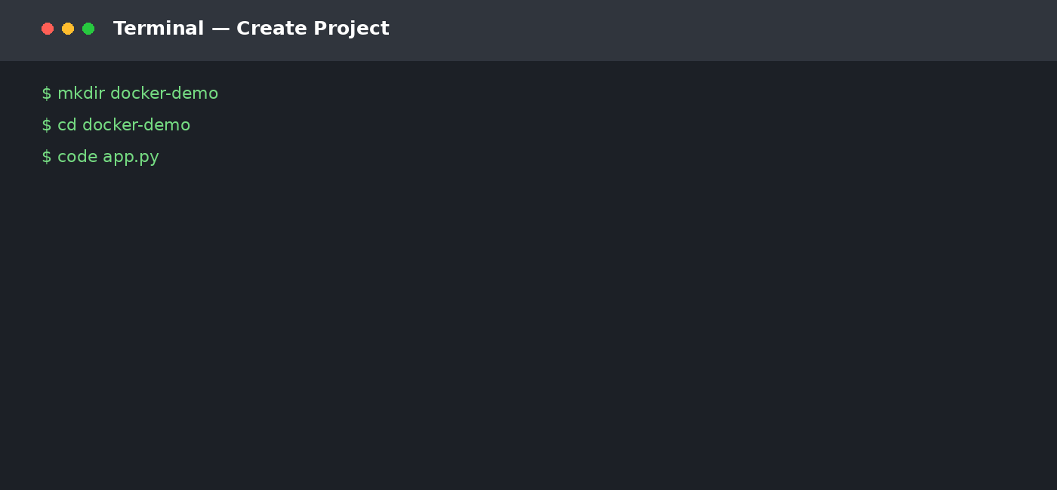
mkdir docker-demo
cd docker-demo

6. Step 3 — Create app.py
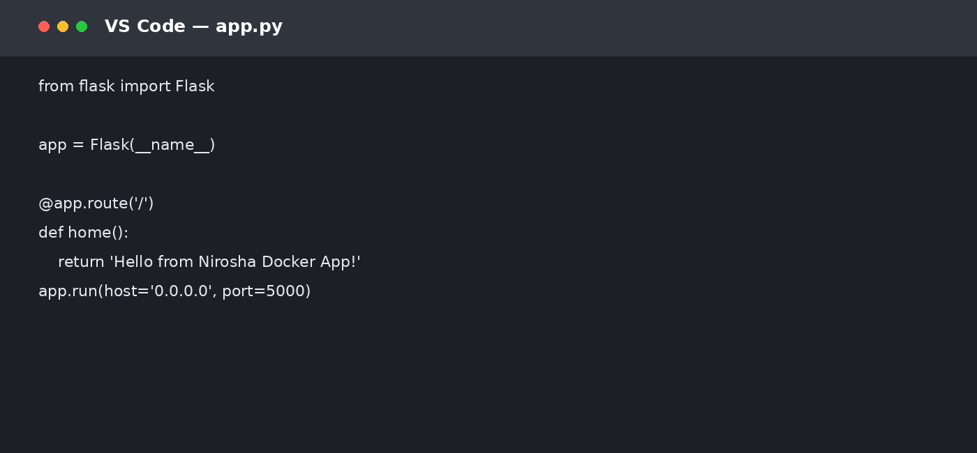

7. Step 4 — Create requirements.txt and Dockerfile
requirements.txt:
Flask==3.1.0
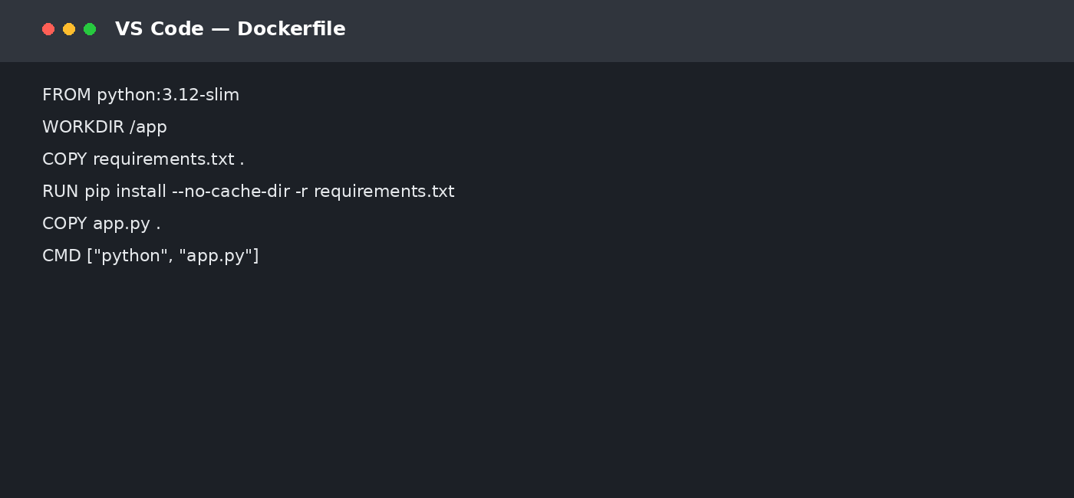

8. Step 5 — Build the Image
docker build -t nirosha-docker-app:1.0 .
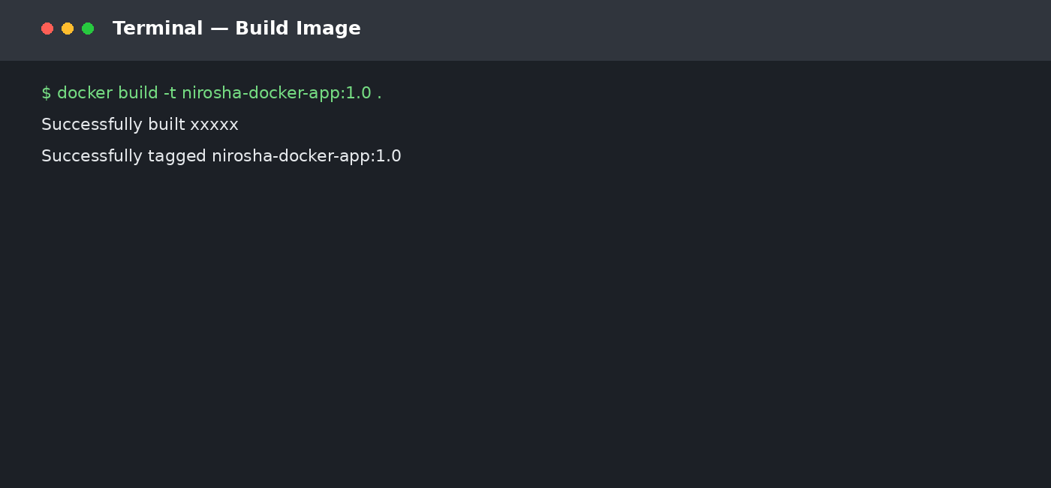

9. Step 6 — Run the Container
docker run -d --name nirosha-app -p 5000:5000 nirosha-docker-app:1.0
docker ps
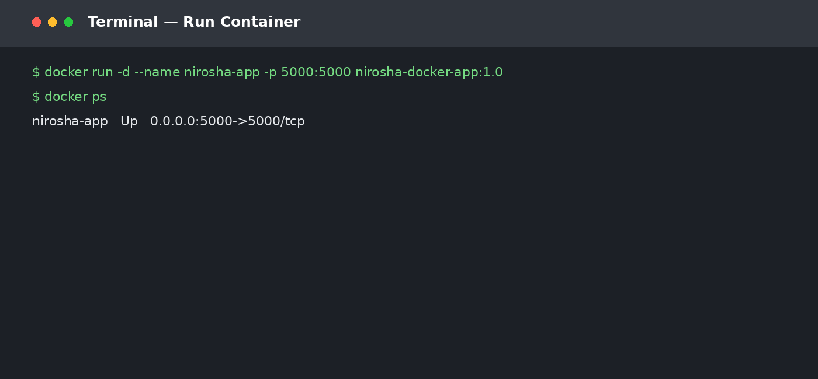

10. Step 7 — Verify
Open http://localhost:5000
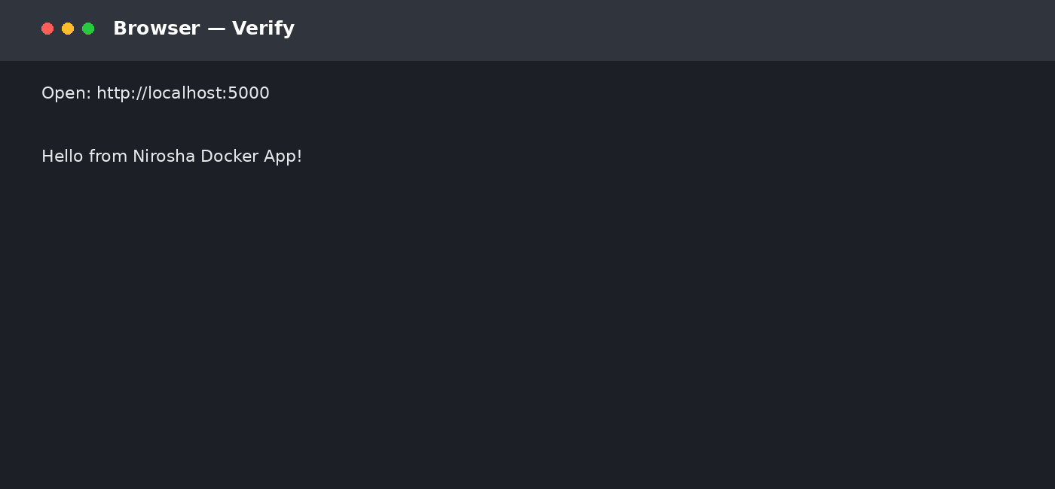

11. Docker Workflow
app.py + requirements.txt
↓
Dockerfile
↓
docker build
↓
Image
↓
docker run
↓
Container
↓
localhost:5000

12. Optional Cleanup
docker stop nirosha-app
docker rm nirosha-app
docker rmi nirosha-docker-app:1.0

13. Submission Evidence
- Docker version / hello-world screenshot
- app.py screenshot
- Dockerfile screenshot
- Successful docker build
- docker ps showing running container
- Browser output screenshot

14. Result
The sample application was successfully containerized by creating a Dockerfile, building a Docker image, running it as a container, and verifying the application.

15. Viva Questions
What is a Dockerfile? A text file containing instructions to build an image.
What is a Docker image? A packaged template used to create containers.
What is a container? A running instance of an image.
What does docker build do? Builds an image from the Dockerfile.
What does docker run do? Creates and starts a container.
Why -p 5000:5000? Maps host port 5000 to container port 5000.

16. Student Details
Student Name: __________________________
Roll No.: ______________________________
Section: _______________________________
Docker Hub ID (if required): __________________
Faculty: Nirosha Bandla

STUDENT SETUP GUIDE — TOOLS, DOWNLOADS & REGISTRATION
Complete this setup BEFORE starting the Docker practical

1. Tools Students Must Install
Tool | Status | Purpose
Docker Desktop | REQUIRED | Install Docker Desktop for Windows. Keep Docker Desktop running while doing the practical.
VS Code | REQUIRED | Use it to create/edit app.py, requirements.txt and Dockerfile. Any text editor can also be used.
Git | OPTIONAL | Not required for the basic Docker practical. Install it only if the faculty asks students to submit the project through GitHub.
Web Browser | REQUIRED | Chrome, Edge or Firefox to open http://localhost:5000.
PowerShell / Command Prompt | REQUIRED | Windows already provides these; no separate installation is normally needed.

2. Accounts / Registration
For the basic practical, students DO NOT need to register for Docker Hub or pay for any subscription. Docker Desktop is enough to build and run the local image.
- GitHub account — OPTIONAL for this Docker-only practical; required only if the faculty asks for GitHub repository submission.
- Docker Hub account — OPTIONAL; required only if students are asked to push their Docker image to Docker Hub.
- Paid subscription — NOT REQUIRED for this practical.

3. Recommended Student Setup
Students should have the following before class:
- Windows 10/11 64-bit system with virtualization enabled.
- At least 8 GB RAM is recommended for comfortable Docker Desktop use.
- Stable internet connection for the initial Docker image download.
- At least 5–10 GB free disk space for Docker Desktop and images.
- Administrator permission may be required during Docker Desktop installation.

4. Installation Order
1. Install Docker Desktop.
2. Restart the computer if Docker Desktop requests it.
3. Open Docker Desktop and wait until it shows that Docker is running.
4. Install VS Code.
5. Open PowerShell and verify Docker.
6. Only after Docker is working, start the practical.

5. First Verification — Students Must Do This
Open PowerShell and type:
docker --version
docker run hello-world
Expected result: Docker displays its version and the 'Hello from Docker!' confirmation message.
If this does not work, do NOT continue with docker build. First open Docker Desktop and confirm that Docker Engine is running.

6. Files Students Will Create
docker-demo/
├── app.py
├── requirements.txt
└── Dockerfile

7. Exact Practical Sequence
Step | Student Action
Create folder | mkdir docker-demo → cd docker-demo
Create application | Create app.py using the sample code in the previous section.
Create dependency file | Create requirements.txt and enter Flask==3.1.0.
Create Dockerfile | Enter the Dockerfile instructions shown in the practical.
Build image | docker build -t nirosha-docker-app:1.0 .
Check image | docker images
Run container | docker run -d --name nirosha-app -p 5000:5000 nirosha-docker-app:1.0
Check container | docker ps
Test application | Open http://localhost:5000
Stop after demonstration | docker stop nirosha-app

8. Important: What Students Do NOT Need
- No AWS/Azure/GCP account is required.
- No Docker Hub registration is required for local execution.
- No paid Docker subscription is required for this classroom exercise.
- No Kubernetes or Minikube installation is required.
- No database installation is required.

9. If Faculty Wants Docker Hub Submission
Only if the faculty specifically asks students to publish the image:
- Create a Docker Hub account.
- Create a public repository, for example: nirosha-docker-app.
- Sign in from the terminal using docker login.
- Tag the image with the Docker Hub username.
- Push the image using docker push.
- Submit the Docker Hub repository URL.
Students should not create a Docker Hub account just for this practical unless submission instructions require it.

10. Student Checklist Before Submission
☐ Docker Desktop installed and running
☐ docker --version successful
☐ docker run hello-world successful
☐ app.py created
☐ requirements.txt created
☐ Dockerfile created
☐ Docker image built successfully
☐ Container shown by docker ps
☐ Application opens at localhost:5000
☐ Required screenshots captured
☐ Student name and roll number added

11. Suggested Screenshot Naming
- 01_Docker_Version_Name.jpg
- 02_Hello_World_Name.jpg
- 03_App_Py_Name.jpg
- 04_Dockerfile_Name.jpg
- 05_Docker_Build_Name.jpg
- 06_Docker_Image_Name.jpg
- 07_Docker_PS_Name.jpg
- 08_Browser_Output_Name.jpg

12. Final Student Instruction
Complete the software installation and Docker verification before the practical session. Students are expected to perform the commands themselves and capture evidence from their own system. Do not submit the sample screenshots as proof of execution.

